C ++ (Linux Commands )

1. 1. dir (Windows) / ls (Linux/macOS): Lists the contents of a directory.

Use Case: You want to see all the files and folders in your current location.

Exercise: Open a terminal window (Command Prompt on Windows, Terminal on macOS/Linux) and type dir (Windows) or ls (Linux/macOS). Press Enter.

Linux :

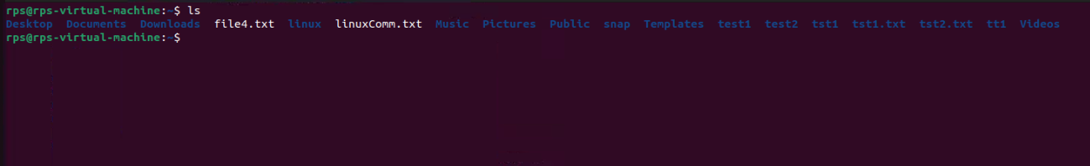

Windows :

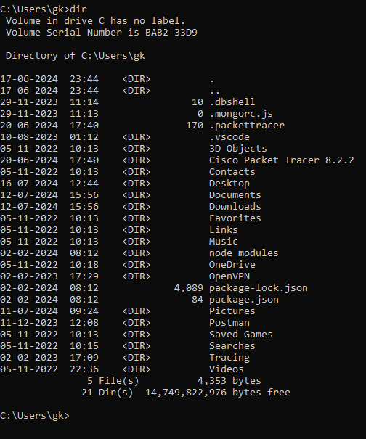

2. cd (all): Changes the current directory.

Use Case: You want to navigate to a different folder on your computer.

Exercise: Try cd Desktop (Windows/Linux/macOS) to navigate to your Desktop folder. Then use dir (Windows) or ls (Linux/macOS) to see the contents.

Linux :

Capture1.PNG

Windows :

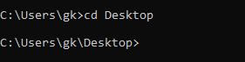

3. mkdir (all): Creates a new directory.

Use Case: You want to organize your files by creating a new folder.

Exercise: Use mkdir Documents (Windows/Linux/macOS) to create a new folder named "Documents". Then use dir (Windows) or ls (Linux/macOS) to see if it's there.

Linux :

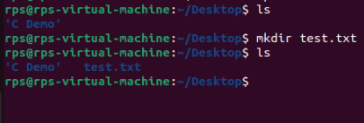

Windows :

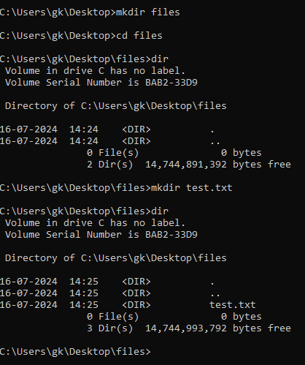

4. rm (Linux/macOS) / del (Windows): Deletes a file or directory (use with caution!).

Use Case: You want to remove an unwanted file or folder.

Exercise: Important: Never delete anything critical! In a safe space (like a temporary folder), create a text file named "test.txt" and then use rm test.txt (Linux/macOS) or del test.txt (Windows) to delete it.

Linux:

Capture5.PNG

Windows :

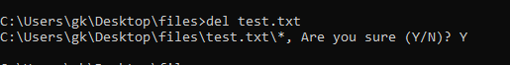

5. copy (Windows) / cp (Linux/macOS): Copies a file.

Use Case: You want to duplicate a file to another location.

Exercise: Create another text file named "test2.txt". Use copy test.txt test2.txt (Windows) or cp test.txt test2.txt (Linux/macOS) to copy "test.txt" as "test2.txt".

Linux :

Capture4.PNG

Windows :



6. move (Windows) / mv (Linux/macOS): Moves a file from one location to another.

Use Case: You want to organize your files by moving them to a different folder.

Exercise: Use move test2.txt Documents (Windows) or mv test2.txt Documents (Linux/macOS) to move "test2.txt" to the "Documents" folder (assuming it exists).

Linux :

Capture6.PNG

Windows :



7. rename (Windows) / mv (Linux/macOS): Renames a file.

Use Case: You want to give a file a different name.

Exercise: Use rename test.txt newname.txt (Windows) or mv test.txt newname.txt (Linux/macOS) to rename "test.txt" to "newname.txt".

Linux :

Capture7.PNG

Windows :

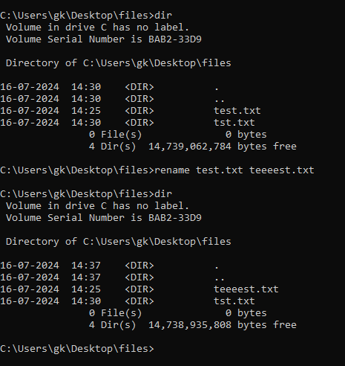

8. ping (all): Checks if another computer is reachable on a network.

Use Case: You want to see if you can connect to a website or another device.

Exercise: Use ping google.com (all) to see if you can reach Google's servers.

Linux :

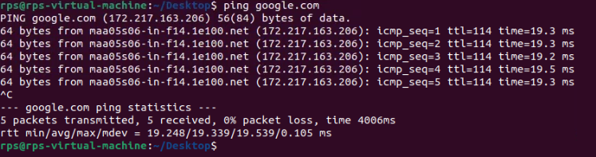

Windows :

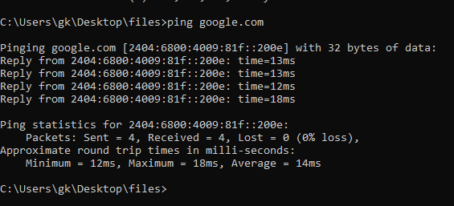

9. ipconfig (Windows) / ifconfig (Linux/macOS): Shows network configuration information.

Use Case: You want to troubleshoot network connectivity issues.

Exercise: Use ipconfig (Windows) or ifconfig (Linux/macOS) to see your IP address and other network details.

Linux :

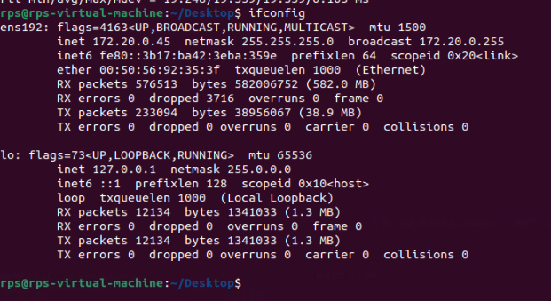

Windows :

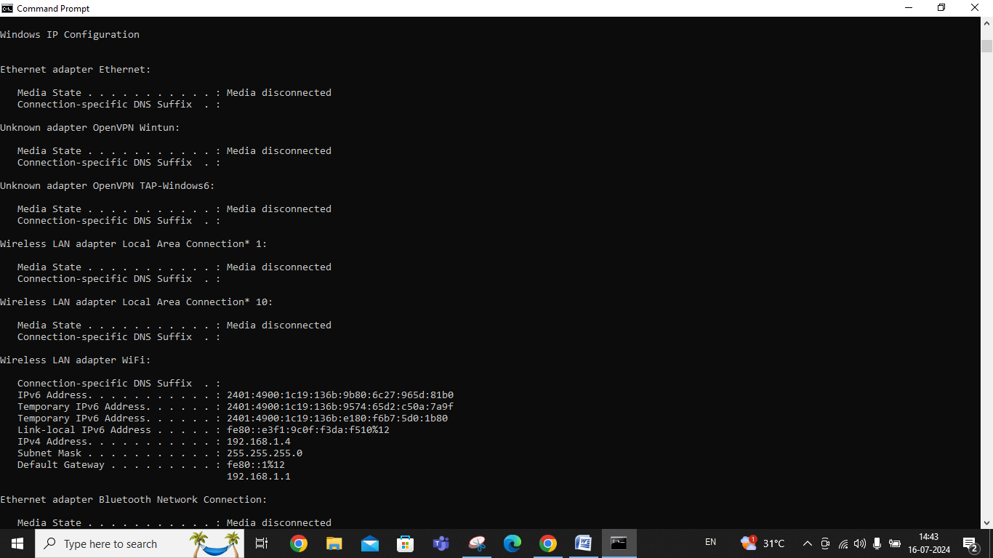

10. help (all): Provides help information for other commands.

Use Case: You're unsure about how to use a specific command.

Exercise: If you're stuck on command like mv, type help mv (all) to see a manual page with usage information.

Linux :

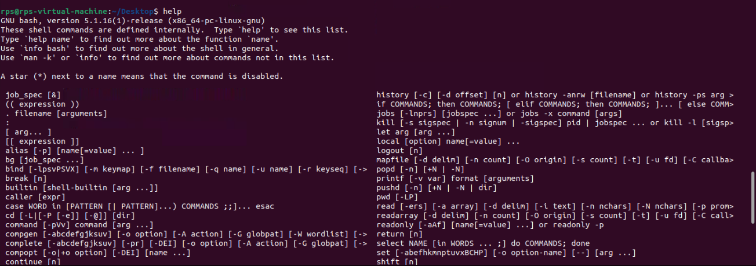

Windows :

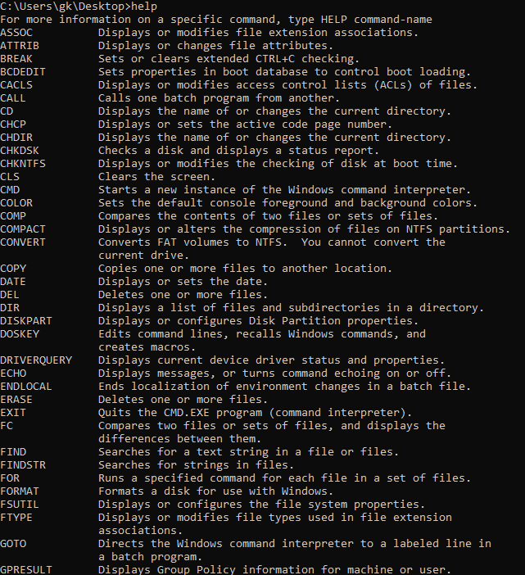

11. clear (all): Clears the screen (text) in the terminal window.

Use Case: Your terminal window is cluttered with previous commands, and you want a clean slate.

Exercise: Type clear (all) to clear the screen.

Linux : Clear all screen

Windows : Clear all screen

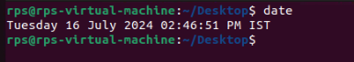

Windows :

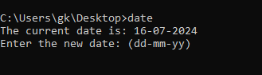

14. time (all): (continued) You want to see how long a command takes to execute.

Exercise: Try time ls (all) to see how long it takes to list the directory contents.

Linux :

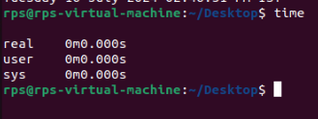

Windows :



15. mkdir -p (Linux/macOS): Creates a directory and any missing parent directories.

Use Case: You want to create a new folder within a nested structure that might not exist yet.

Exercise: Use mkdir -p Documents/Subfolder1/Subfolder2 (Linux/macOS) to create "Subfolder2" within "Subfolder1" inside the "Documents" folder (assuming "Documents" exists).

16. cat (Linux/macOS): Displays the contents of a text file.

Use Case: You want to read the contents of a text file without opening it in a separate program.

Exercise: Create a text file with some content and use cat filename.txt (Linux/macOS) to see its contents.

17. echo (all): Prints text to the terminal window.

Use Case: You want to display a message or variable in the terminal.

Exercise: Use echo Hello, world! (all) to print the message to the screen.

Linux :

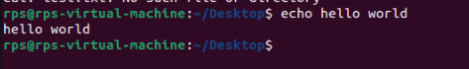

Windows :

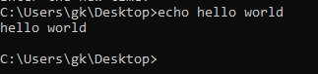

18. sudo (Linux/macOS): Grants temporary superuser privileges to execute a command (use with caution!).

Use Case: You need to perform an action that requires administrative rights.

Exercise: Important: Never use sudo for untrusted commands! In a safe scenario (like creating a test file), use sudo touch important.txt to create a file that might require admin access (assuming you have the password).

Linux :

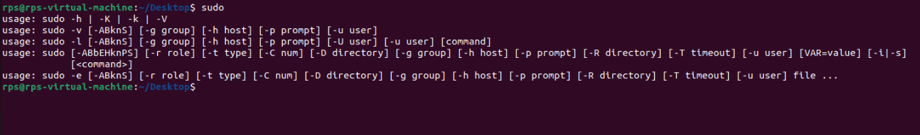

19. shutdown (Linux/macOS) / shutdown /s /t (Windows): Initiates a system shutdown or restart.

Use Case: You want to turn off or restart your computer.

Exercise: Important: Don't accidentally shut down your computer! This is for learning purposes only. Look up the specific options for your system to safely test a shutdown with a delay (e.g., shutdown /s /t 60 for Windows to shutdown in 60 seconds).

20. history (all): Shows a list of previously entered commands.

Use Case: You want to see what commands you've used recently, in case you need to refer back to one.

Exercise: Type history (all) to see a list of your recent commands.

Linux :

